TUTORIAL SHEET-1

**Course:** B.Tech (CSE) **Subject:** Computer Networks **Subject Code:** BCSC0008 **Session:** 2024-25

**Q1.** Assume six devices are arranged in a mesh topology. How many cables are needed? How many ports are needed for each device?

**Q2.** For each of the following four networks, discuss the consequences if a connection fails.

1. Five devices arranged in a mesh topology
2. Five devices arranged in a star topology (not counting the hub)
3. Five devices arranged in a bus topology
4. Five devices arranged in a ring topology

**Q3.** You have two computers connected by an Ethernet hub at home. Is this a LAN, a MAN, or a WAN? Explain your reason.

**Q4.** Compare the telephone network and the Internet. What are the similarities? What are the differences?

**Q5.** In the following figure, what happens if one of the stations is unplugged?

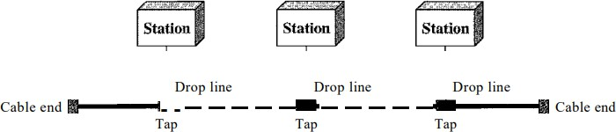

**Q6.** In the following figure, what happens if one of the stations is unplugged?

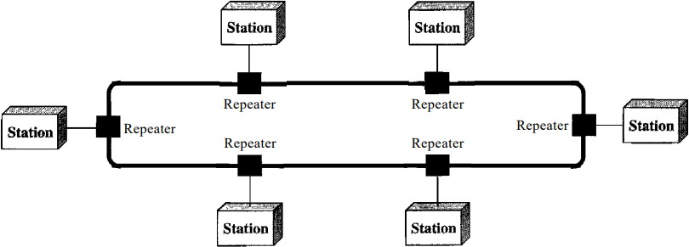

**Q7.** Draw a hybrid topology with a ring backbone and two bus networks.

**Q8.** Draw a hybrid topology with a star backbone and three ring networks.